**KENDRIYA VIDYALAYA RAJKOT**

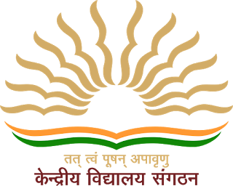

**SUBMITTED TO AISSCE 2019-20**

**CS PROJECT**

**LIBRARY MANAGEMENT**

**SUBMITTED TO: - SUBMITTED BY:-**

**MR. PRADEEP MANCHANDIA SANKALP KANCHAN**

**PGT-C.S. CLASS XII-A**

**CERTIFICATE**

This is to certify that this project work is submitted by DARSHIL SOLANKI and SANKALP KANCHAN to the CS department, KENDRIYA VIDYALAYA RAJKOT, GUJRAT was carried out by him under the guidance & supervision during academic year 2019-20.

MR. PRADEEP MANCHANDIA MR AK GUPTA

(PGT-CS) SCHOOL PRINCIPAL

KV RAJKOT

EXAMINER SIGN: -

ACKNOWLEDGEMENT

I WOULD LIKE TO EXPRESS MY GRATITUDE TO ALL THE PEOPLE WHO ARE ASSOCIATED TO THIS PROJECT IN ONE WAY OR ANOTHER.

FIRST OF ALL, I WOULD LIKE TO THANK OUR WORTHY PRINCIPAL **MR. A. K. GUPTA**, KENDRIYA VIDYALAYA RAJKOT, FOR PROVIDING SUPPORT AND NECESSARY INFRASTRUCTURE FOR COMPLETION OF PROJECT.

THANKING **MR. PRADEEP MANCHANDIYA SIR**, OUR HONOURED AND DEDICATED COMPUTER SCIENCE TEACHER, WHO GUIDED US THROUGHOUT THE PORJECT. A SINCERE THANKS TO EVERYONE WHO PROVIDED THE RESOURCES WHICH WERE REFERRED TO DURING THE FABRICATION OF THIS SOFTWARE.A SPECIAL THANKS TO ALL MY FRIENDS, WHO HELPED A LOT IN EDITING, SIMPLIFYING AND DEBUGGING THE SOFTWARE.

THANK YOU TO ALL OF YOU FOR SO MUCH SUPPORT WITHOUT WHICH THE DEVELOPMENT OF THIS ‘SOFTWARE’ WOULD NOT HAVE BEEN POSSIBLE.

PREFACE

THIS PROJECT, A COMBINED EFFORT OF TWO STUDENTS, **SANKALP KANCHAN** AND **DARSHIL SOLANKI** HAS BEEN DONE AS A PART OF OUR CLASS 12 CURRICULUM. AS PER THE GUIDELINES WE RECEIVED TO CREATE THE PROJECT, WE BASICALLY HAD TO CREATE A PROJECT ON OUR RESPECTIVE TOPICS AND HAD TO INCLUDE THE FOLLOWING THINGS:

* USE OF OBJECT-ORIENTED TECHNOLOGY
* USE OF DATA FILES
* AN INNOVATIVE IDEA

AFTER SOME SERIOUS HARD WORK WE WERE ABLE TO COMPLETE THE PROJECT AND HAVE KEPT IN MIND TO INCLUDE THE ABOVE MENTIONED THINGS.

INDEX

* Python programming language
* What python can do?
* Why python?
* Library management
* Source code
* Output
* Bibliography

PYTHON PROGRAMING LANGUAGE

Python is a widely used general-purpose, high level programming language. It was initially designed by Guido van Rossum in 1991 and developed by Python Software Foundation. It was mainly developed for emphasis on code readability, and its syntax allows programmers to express concepts in fewer lines of code.

Python is a programming language that lets you work quickly and integrate systems more efficiently.

### What can Python do?

* Python can be used on a server to create web applications.
* Python can be used alongside software to create workflows.
* Python can connect to database systems. It can also read and modify files.
* Python can be used to handle big data and perform complex mathematics.
* Python can be used for rapid prototyping, or for production-ready software development.

### Why Python?

* Python works on different platforms (Windows, Mac, Linux, Raspberry Pi, etc).
* Python has a simple syntax similar to the English language.
* Python has syntax that allows developers to write programs with fewer lines than some other programming languages.
* Python runs on an interpreter system, meaning that code can be executed as soon as it is written. This means that prototyping can be very quick.
* Python can be treated in a procedural way, an object-orientated way or a functional way.

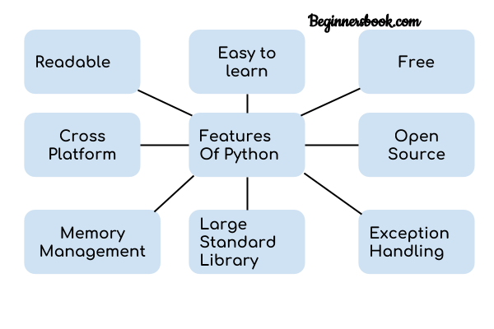

1. **Readable:** Python is a very readable language.

2. **Easy to Learn:** Learning python is easy as this is a expressive and high level programming language, which means it is easy to understand the language and thus easy to learn.

3. **Cross platform:** Python is available and can run on various operating systems such as Mac, Windows, Linux, Unix etc. This makes it a cross platform and portable language.

4. **Open Source:** Python is a open source programming language.

5. **Large standard library:** Python comes with a large standard library that has some handy codes and functions which we can use while writing code in Python.

6. **Free:** Python is free to download and use. This means you can download it for free and use it in your application.

7. **Advanced features:** Supports generators and list comprehensions. We will cover these features later.

8. **Automatic memory management:** Python supports automatic memory management which means the memory is cleared and freed automatically. You do not have to bother clearing the memory.

LIBRARY MANAGEMENT

Library management is a program designed to provide libraries an easier method to sort, maintain and manage their libraries. This program intends on the duality of online database via django and also provides security as a login system to the librarian. This program can keep tabs on all the books being issued, returned, modified and reserved. Because it would be difficult to search for the details of each and every book, it creates a separate file for each book and member in case anyone needs immediate access to it. Given below are some key features of the program: -

**User friendly:** - this program offers options features as it is developed on the module of PrettyTable

**Parallel-based operations: -** this program works on both the system i.e. list manipulations and file handling

**Multi-user options:** -this program offers functionality requirements as per the host i.e. librarian/member

**Online database: -** the most challenging part of the program was to connect django as an online database to the programme in case the user wants online support

**Basic functionalities added: -** we added the basic functionalities such as book issuing/returning/ reserving/ multiple entries and the constant updates that keep occurring of the number of books at a library

**Member cycling: -** added functionality of adding/deleting members with additional info and also made sure only members can access the system.

**OUTPUT**



